**Master Functional Document**

|  |  |
| --- | --- |
| **Application** | NGERP - Centra |
| **Service Bundle** | Master Management |
| **Service Request** | Sales Rep Info |

**Description :**

The Sales Rep Master is used to show the basic information about the representative and invoices, orders Customer RMA and commercial discount made by a particular sales representative.

**Workflow Process :**

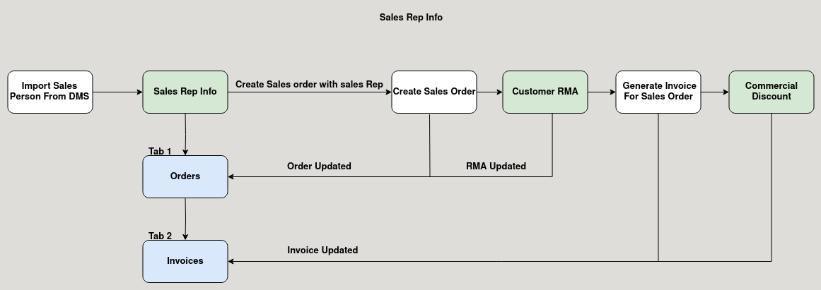

**Business Rules :**

* The Sales rep master screnn gets its data from the sales person master.
* It show the basic details of the sales representative.
* It shows all the sales order, invoices and Customer RMA made by the sales person.
* It shows the sales order, invoice, Customer RMA and Commercial discount of all document status (Completed, Draft, Inprogress, Invalid)